# CS 255 System Design Document Template

This template lays out all the different sections that you need to complete for Project Two. Each section has guidance to prompt your thinking. You will need to continually reference the interview transcript as you work to make sure that you are addressing your client’s needs. There is no required length for the final document. Instead the goal is to complete each section based on what your client’s needs are. Remove this note when you are finished, and replace all bracketed text with the relevant information.

## UML Diagrams

### UML Use Case Diagram

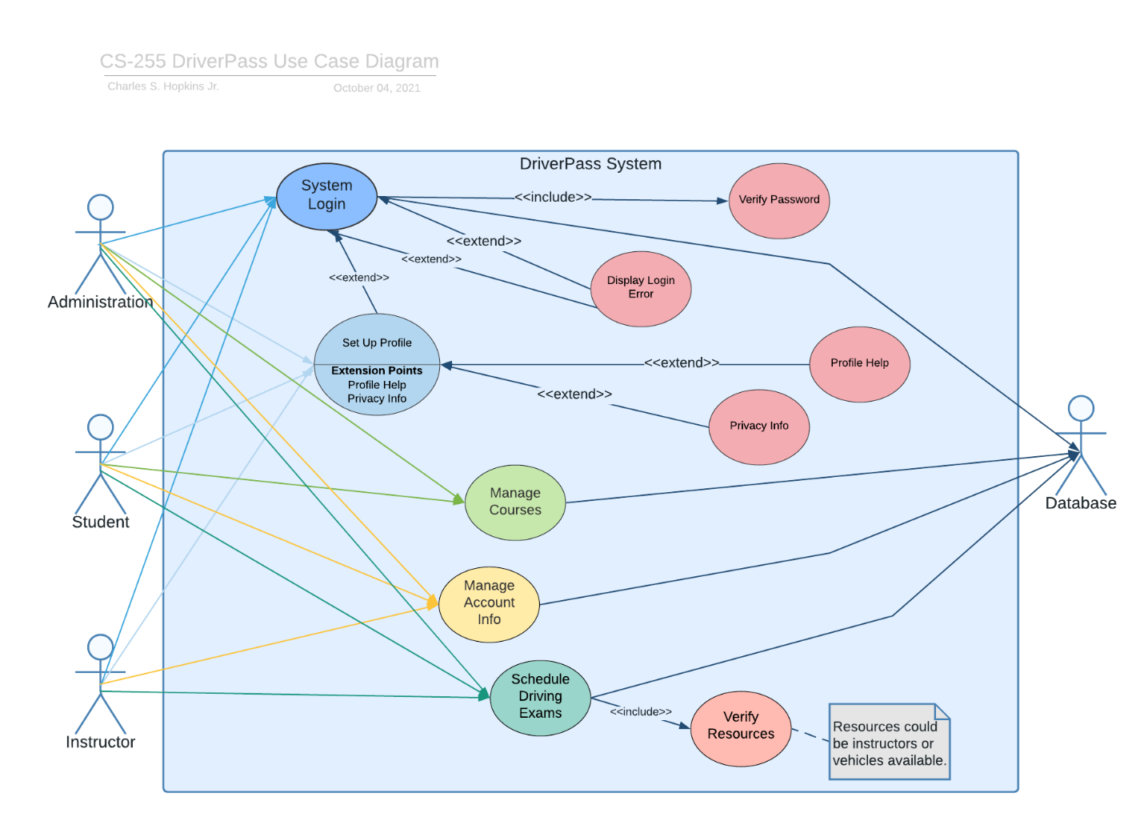

### UML Activity Diagrams

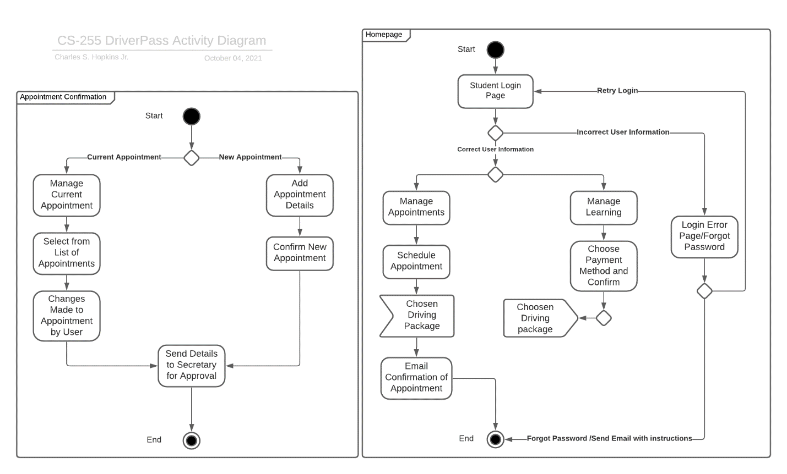

### UML Sequence Diagram

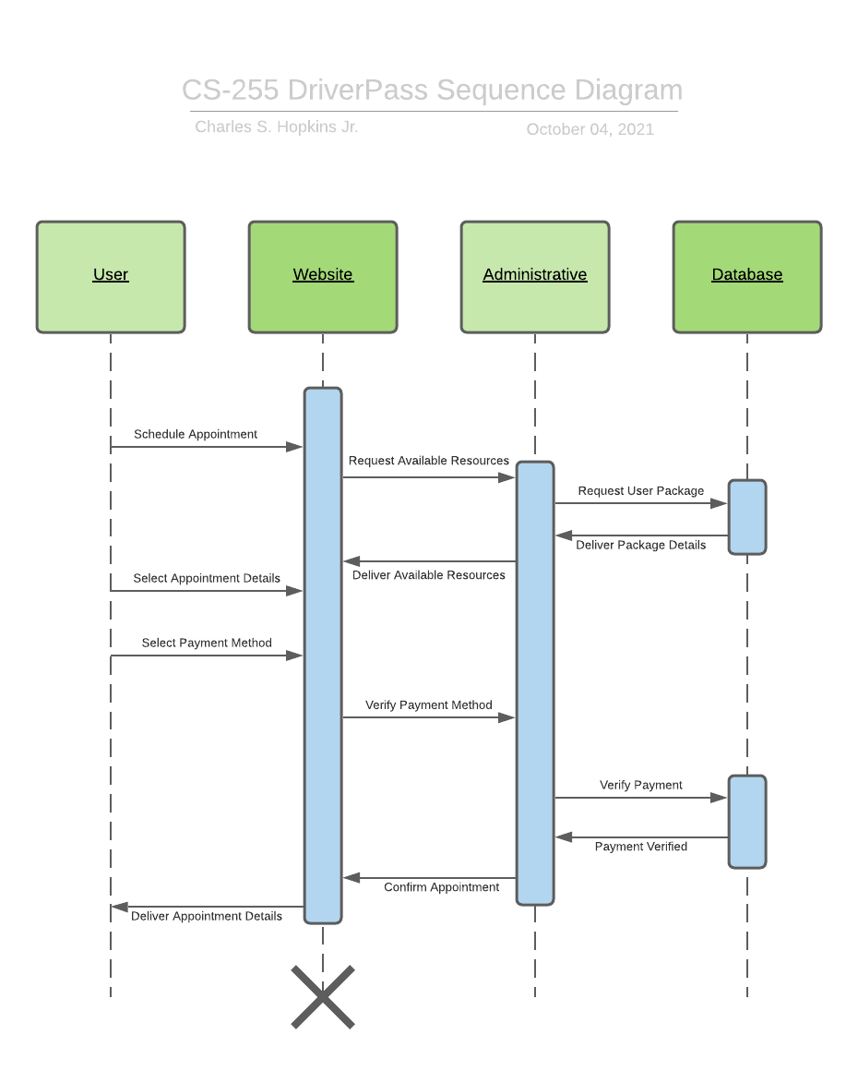

### UML Class Diagram

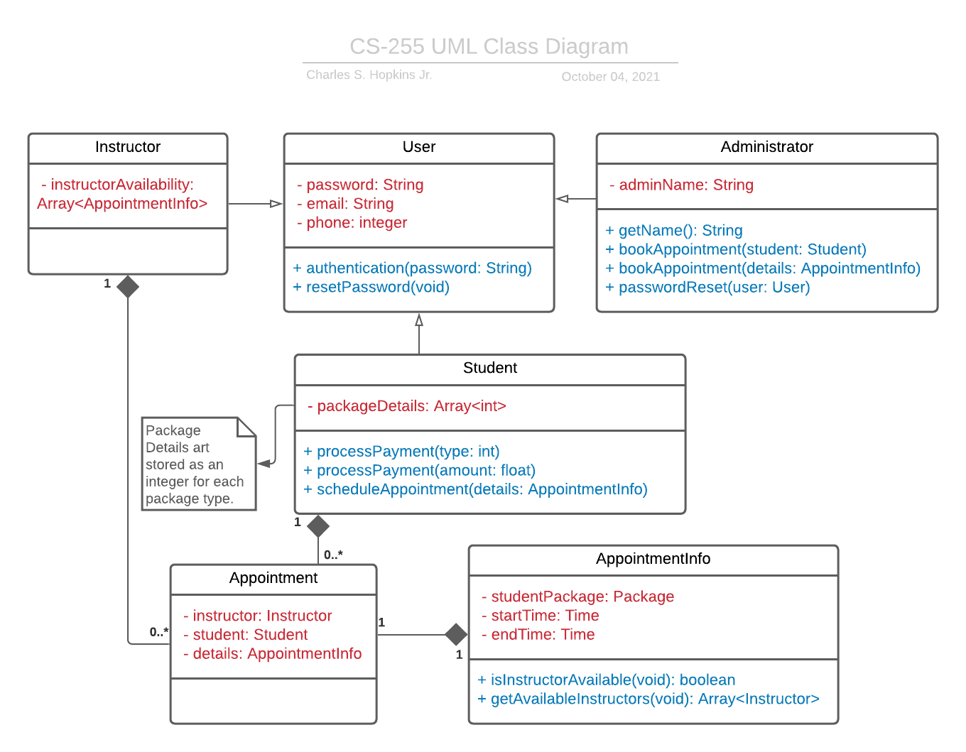

## Technical Requirements

For administrators, there will need to be a network interface in place outside of the system itself. A database capable of storing user information securely would also be needed. This database would need the same if not a stronger level of security to protect student information. There will need to be a database maintained by administrators both physically and virtually. There must be a method for online payments to be made securely and perhaps Paypal support to account for a variety of payment types.